Indian Market Analysis

India has many stock market indices, including the S&P BSE Sensex, NSE Nifty 50 and Bank Nifty

Here are some of the most popular:

* S&P BSE Sensex: The oldest and most popular market index, representing the Bombay Stock Exchange (BSE).
* NSE Nifty 50: Represents the performance of the top 50 largest companies on the National Stock Exchange (NSE).
* S&P BSE Sensex Next 50: A BSE index that represents the market.
* BSE Healthcare Index: An index that focuses on specific sectors.
* BSE Banker Index: An index that focuses on specific sectors.
* NSE IT Index: An index that focuses on specific sectors.

*This is not professional financial advice. Consulting a financial advisor about your particular circumstances is best.*

In this report we Analysed three Key Indices:

* + Nifty 50
  + Bank Nifty
  + Sensex

By

Nitish Kusalkar

Content:

1. Introduction % Dashboard Overview
2. Key Finding
3. Data Analysis
4. Visual Aids
5. Conclusion
6. Reference

* Introduction:

In this project we created the multiple dashboards which is shown /explain about the basic information of the Indian markets.

The Nifty 50, Bank Nifty and Sensex is an index of the largest companies listed on the National Stock Exchange (NSC) and Bombay Stock Exchange (BSC) of India. The Dashboards shows the overview of the performance of indices, including the total market capitalization, Weightage, LTP (Last Trade Price), and so on.

* Key Finding

Total Companies by Sectors

Total Weightage by Sectors

Total weightage by all companies

All companies by market capital

Total LTP

Average of weightage

Average of Change%

Total Companies, Sectors and weightage

* Data Analysis:

1. Nifty 50 Analysis Dashboards 1 & 2
2. Bank Nifty Analysis Dashboard
3. Sensex Analysis Dashboard

Nifty 50 Analysis Dashboards 1 & 2

**Total Market Cap**: This section shows the total market capitalization of the Nifty 50 index in crores. It is currently 17.79 million crores.

**Change %:** The percentage change of the Nifty 50 index at 13 February is displayed in this view of the dashboard.

**Total Weightage by Sectors**: This section likely shows the weightage of different sectors in the Nifty 50 index

Bank Nifty Analysis Dashboard

**Total Market Cap**: This section shows the total market capitalization of the Bank Nifty index in crores. It is currently 4 million crores.

**Change %:** The percentage change of the Bank Nifty index at 13 February is displayed in this view of the dashboard.

**Weightage by Companies**: This section shows the weightage of the top companies in the Bank Nifty index. Axis Bank is the company with the highest weightage (3.71%).

Sensex Analysis Dashboard

**Total Market Cap:** This section shows the total market capitalization of the Sensex index in crores. It is currently 14.55 million crores.

**Change %:** The percentage change of the Sensex index is at 13 February is displayed in this view of the dashboard.

**Weightage by Companies**: This section shows the weightage of the top companies in the Sensex index. Reliance Industries Limited (RIL) is the company with the highest weightage (12.9%).

* Visual Aids:

Dashboard 1

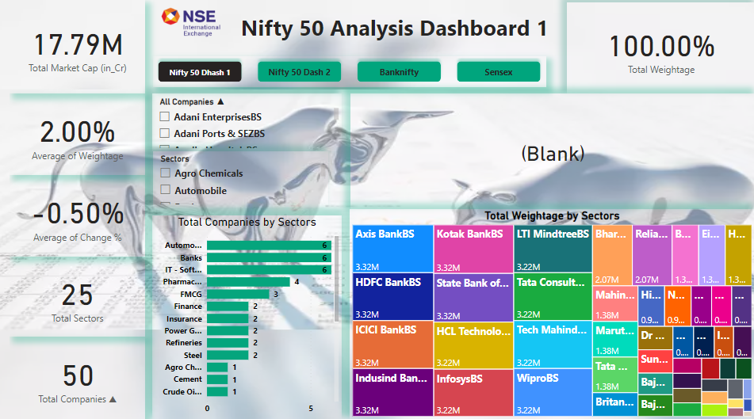

Dashboard 2

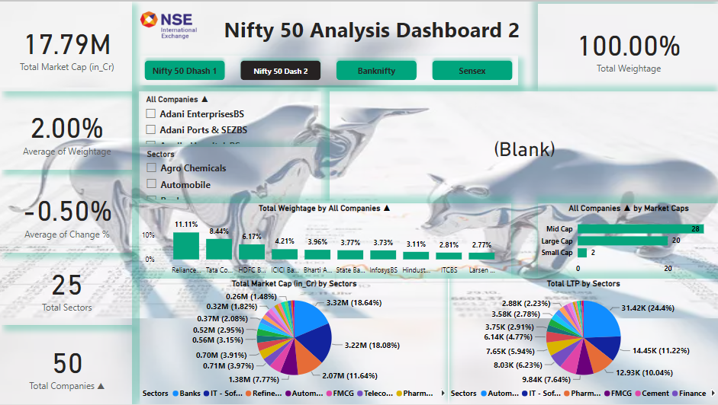

Dashboard 3

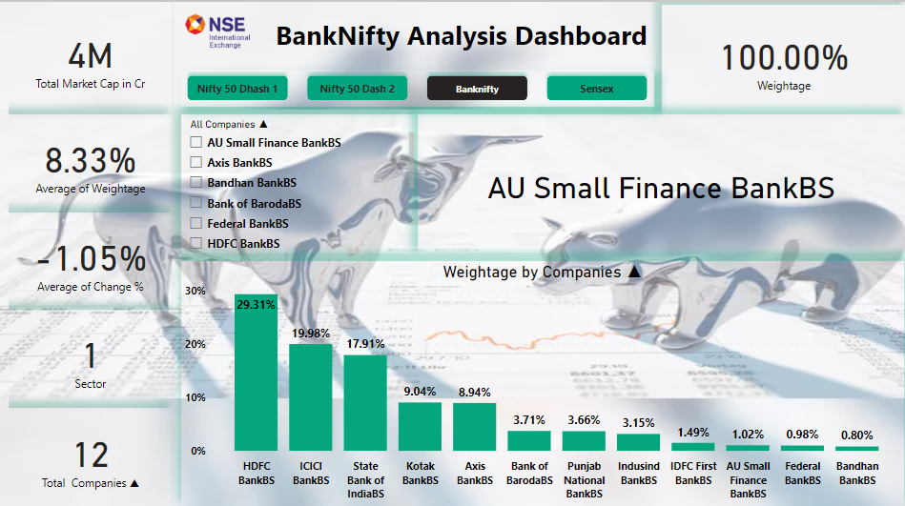

Dashboard 4

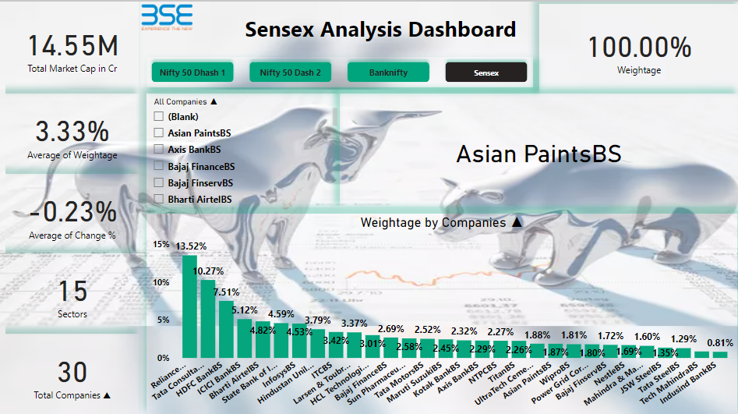

* Conclusion

The conclusion that can be drawn from this dashboard is limited given the specific data points displayed. The Nifty 50 and Sensex indexes are both down around half a percent, while the Bank Nifty is down over 1%.

Here are some additional things:

• Trends over time:

How have these indexes performed over the past week, month, or year?

• News and events:

Has there been any recent news that could be affecting the market?

• Other economic indicators:

How is the overall economy doing?

* Reference

[www.dhan.com](http://www.dhan.com)

[www.money](http://www.money)control.com

www.investing.com